# WEEK 2: FINDING TIME COMPLEXITY

### PROGRAM 1:

**AIM:**

Convert the following algorithm into a program and find its time complexity using the counter method.

void function (int n)

{

int i= 1;

int s =1;

while(s <= n)

{ i++;

s += i;

}

}

### ALGORITHM:

Step 1: Initiliaze a counter variable c=0 Step 2: Place c++ after each statement Step 3: Display c

### PROGRAM:

­#include<stdio.h>

int count=0;

void func(int);

void func(int n)

{

int i=1;

count++;

int s=1;

count++;

while(s<=n)

{

count++;

i++;

count++;

s+=i;

count++;

}

count++;

}

int main()

{

int n;

scanf("%d",&n);

func(n);

printf("%d",count);

}

### OUTPUT:

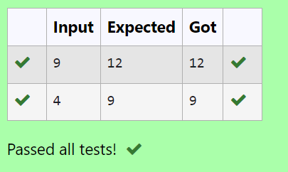

**RESULT:** Thus the program is executed successfully.

### PROGRAM 2:

**AIM:**

Convert the following algorithm into a program and find its time complexity using the counter method.

void func(int n)

{

if(n==1)

{

printf("*");

}

else

{

for(int i=1; i<=n; i++)

{

for(int j=1; j<=n; j++)

{

printf("*");

printf("*"); break;

}

}

}

}

### ALGORITHM:

Step 1: initialize a counter variable c=0

Step 2: Place c++ after each iteration of a loop and declaration of a statement. Step 3: Display c

### PROGRAM:

#include<stdio.h>

int count=0;

void func(int n)

{

if(n==1)

{

count++;

//printf("*");

}

else{

count++;

for(int i=1;i<=n;i++)

{

count++;

for(int j=1;j<=n;j++)

{

count++;

//printf("*");

count++;

//printf("*");

count++;

break;

}

count++;

}

count++;

}

}

int main()

{

int n;

scanf("%d",&n);

func(n);

printf("%d",count);

}

### OUTPUT:

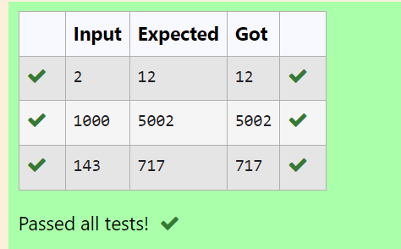

**RESULT:** Thus the program executed successfully.

### PROGRAM 3:

**AIM:**

Convert the following algorithm into a program and find its time complexity using counter method.

Factor(num) {

{

for (i = 1; i <= num;++i)

{

if (num % i== 0)

{

printf("%d ", i);

}

}

}

### ALGORITHM:

Step 1: initialize a variable c=0

Step 2: Place c++ after each iteration of a loop. Step 3: display c

### PROGRAM:

#include <stdio.h>

int count=0;

void Factor(int);

void Factor(int num)

{

for(int i=1;i<=num;++i)

{

count++;

if(num%i==0)

{

count++;

//printf("%d",i);

}

count++;

}

count++;

}

int main()

{

int n;

scanf("%d",&n);

Factor(n);

printf("%d",count);

}

### OUTPUT:

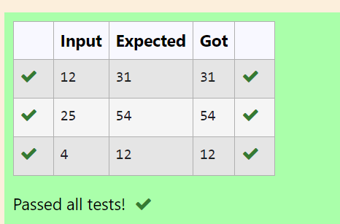

**RESULT:** Thus the program is executed successfully.

### PROGRAM 4:

**AIM:**

Convert the following algorithm into a program and find its time complexity using counter method.

void function(int n)

{

int c= 0;

for(int i=n/2; i<n; i++) for(int j=1; j<n; j = 2 * j)

for(int k=1; k<n; k = k * 2) c++;

}

### ALGORITHM:

Step 1: Initialize a counter variable c=0 Step 2: Place c++ after every loop Step 3: display c

### PROGRAM:

#include<stdio.h>

int count=0;

void function(int);

void function(int n)

{

int c=0;

count++;

for(int i=n/2;i<n;i++){

count++;

for(int j=1;j<n;j=2*j){

count++;

for(int k=1;k<n;k=k*2){

count++;

c++;

count++;

}

count++;

}

count++;

}

count++;

}

int main()

{

int n;

scanf("%d",&n);

function(n);

printf("%d",count);

### OUTPUT:

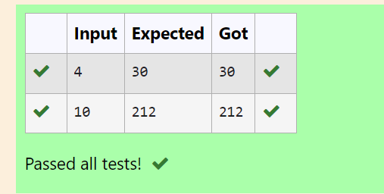

**RESULT:** Thus the program is executed successfully.

### PROGRAM 5:

**AIM:**

Convert the following algorithm into a program and find its time complexity using counter method.

void reverse(int n)

{

int rev = 0, remainder; while (n != 0)

{

remainder = n % 10;

rev = rev * 10 + remainder; n/= 10;

}

print(rev);

}

### ALGORITHM:

Step 1: Initialise the counter variable c=0

Step 2: After every iteration of a loop place a c++ Step 3: Display c

### PROGRAM:

#include<stdio.h>

int count=0;

void reverse(int n)

{

int rev=0,remainder;

count++;

while(n!=0)

{

count++;

remainder=n%10;

count++;

rev=rev*10+remainder;

count++;

n/=10;

count++;

}

count++;

//print(rev)

count++;

}

int main()

{

int n;

scanf("%d",&n);

reverse(n);

printf("%d",count);

}

### OUTPUT:

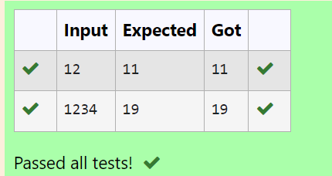

**RESULT:** Thus the program executed successfully.